Use of the LSM 5 Pascal Confocal Microscope

Powering on:
- Turn on switches for 1 (power strip), 2 (mercury lamp), 3 (power strip), 4 (HeNe laser), 5 (HeNe laser), and 6. STOP and wait a few minutes.
- Meanwhile, log in to the user book (black binder above the computer monitors) and record the number of hours on 2 in the log book.
- Turn on 7, then wait a few minutes.
- Turn the knob for 9 counterclockwise until it stops. Dial the voltmeter counterclockwise to 10 A (yellow tape mark).
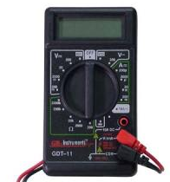
0.60
- Turn on 8 (switch it to the up position). Dial 9 clockwise until the voltmeter reads 0.6 V. Turn off the voltmeter (12:00 position shown above).
- Turn on 10 (computer).
- Open the LSM5 software by double-clicking the icon on the desktop.
- Select Online Mode and press Start.
*If you only wish to work with previously acquired images, you can use Offline Mode and not start up the scope. Just turn on 1 (power strip) and 10 (computer).

Powering off:
- If you used immersion oil, make sure you have cleaned off all objectives used during your session with lens paper. Make sure the 10X objective is returned to the starting position for the convenience of the next user.
- Dial 9 counterclockwise until it stops. Turn off 8 and 7, then STOP and wait until the fan stops.
- Turn off switches for 6, 5, 4, and 3.
- Before turning off 2, record the number of hours displayed in the log book.
- Turn off 2 and 1.
- When closing the software, make sure that you have exported any images you wish to keep. Save these to an alternative storage device, do not keep them indefinitely on the D:/. In the event of a hard drive failure, you would lose any images that you have not backed up onto a separate device!
- Fill out a charge form for the LSM after each use of the microscope. (Offline mode use is not charged.) The cost is $40 per hour. Record your time in 15 minute increments.

**Allow the lasers 30 minutes to cool down prior to powering them on again. Before starting up the machine, make sure (by checking the log book) that another user has not recently powered off the lasers. Also, before shutting down the system yourself, make sure that another user is not signed up to use the machine immediately behind you (check the sign-up calendar on the back wall).

Setup

Once you have started up the software, the following bar will appear at the top of the screen:
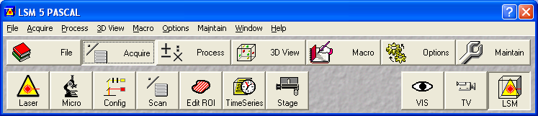
Click on the icons Micro, Config, and Scan to open up 3 additional windows.

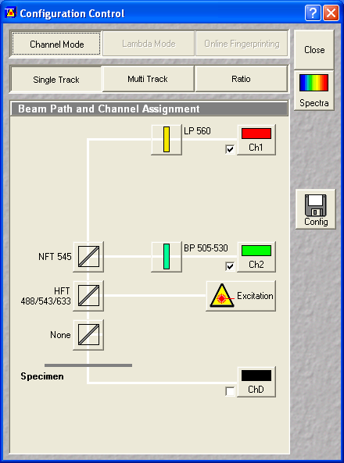
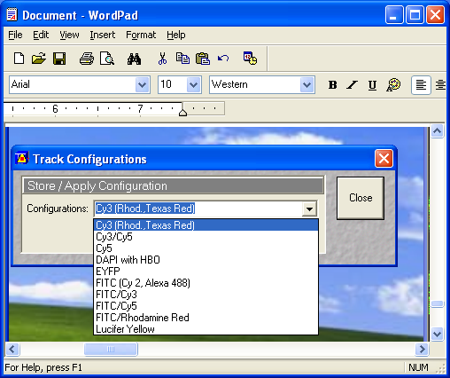
Configuration Control: filter settings

You can view 2 channels with Single Track. To include a third, select Multi Track.

Click on the Config button to open a list of saved configuration settings. Select the channel(s) you wish to use and click Apply then Close. (The filters can be manually adjusted further if needed.)

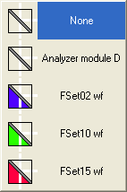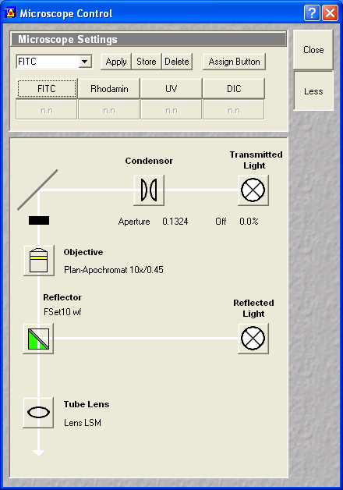
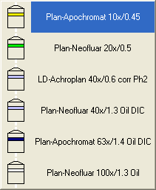
Microscope Control:

Change objectives by clicking on the Objective icon. Note that those requiring immersion oil are designated Oil.

Press the buttons at the top to alternate channels when viewing your specimen through the eyepieces; the correct reflector should also automatically be selected for you.

Click on the Transmitted Light button to adjust the light level for transmitted light (brightfield). Slide the bar in the new window to adjust light intensity.

Click on the Reflected Light button to turn off FITC or Rhodamin.
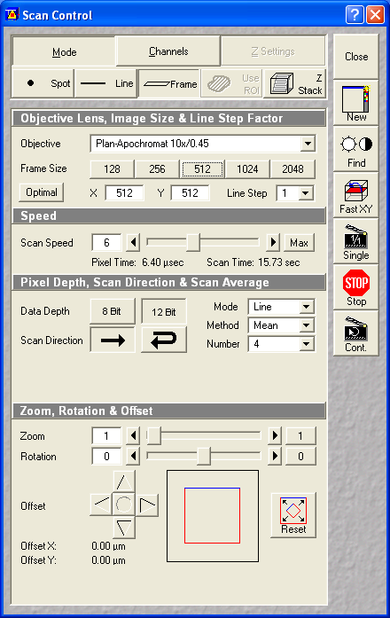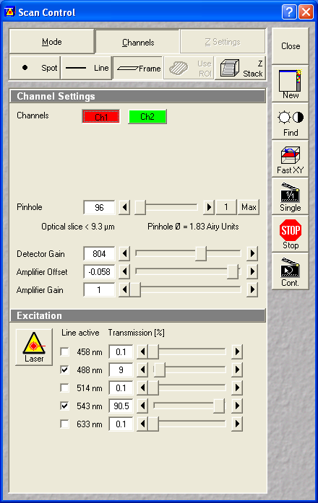
Scan Control – Mode tab:

Generally, image with a frame size of 512 or 1024, either 8 or 12 bit data depth, unidirectional scan. *For optimizing your settings, use a smaller frame size to allow for faster scans and speedier optimization.

For thick tissues, increasing the number of averaged scans will help with the signal to noise ratio. Start with 4 averages. This will increase scan time and file size.

Scan speed can be reduced for higher image quality (and again, a slower scan and larger file).

Scan Control – Channels tab:

Click on each channel icon to adjust channel settings separately.

Make sure that fluorescence channels have the same number reading for the pinhole size. Aim for around 5-10 μm. For fluorescence applications, an Airy value of not less than 1.00 is recommended.

Detector gain – good starting point is between 600-800. Increase if signal on screen appears weak.

Can adjust amplifier offset to help remove background and bring out signal; adjust detector gain before altering amplifier settings.

Transmission % for the green should be about 1/10 that of the red due to the much weaker power of the red laser.

Image Acquisition

Make sure 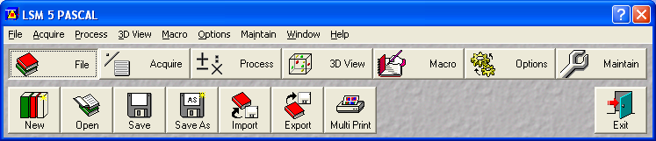 is selected on the main menu bar.
Press to see through eyepieces; to see image on the computer screen and take pictures.

- This is an inverted microscope. Place your slide specimen-side down. If an oil immersion lens is being used, put the drop of oil onto the slide, not the lens, then lay the slide down between the fittings on the scope.
- View your specimen through the microscope. To look at different channels through the eyepieces:
  - Make sure VIS is selected from the main menu bar
  - Use the buttons at the top of the microscope control window to cycle between channels:
click on DIC for white light, FITC for green channel, Rhodamin for red channel
  - Hit the Reflected Light (for fluorescence) or Transmitted Light (for brightfield) button to turn off the light/laser on the sample and limit bleaching. There are also buttons on the scope.
- View your specimen on screen. Make sure LSM is selected. From the Scan Control window, be sure Frame is selected, and click either Find or FastXY to open the image display window. Find is helpful if you’re having trouble bringing your image up on screen.
- Press FastXY (this is a rapid scan of your specimen). Use FastXY to center and focus the image and to make adjustments to any settings, such as:
*Pinhole size (increase slowly if you don’t see an image at all; too large of a pinhole however will reduce your depth of focus and excessively increase light intensity)

*Detector Gain (adjusted for each channel; increase to digitally increase your signal; background will also rise)

*Scan Average number (increase for higher quality)

*Scan Speed (can decrease to make the image less grainy)

*Amplifier Offset (can help remove background and bring out the signal)

- Pressing Stop will terminate the Fast XY scan; try not to scan too long so you don’t burn out the image.
- If you are having difficulty bringing your image up on screen but can see it through the eyepieces, click Find. The software will try to settings that work for you.

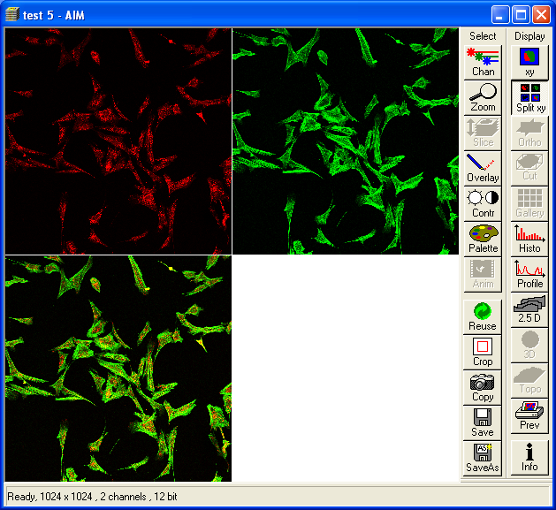
When you press FastXY or Find, a window will pop up showing your image (all channels merged).

Press Split xy if you want to split the image into separate channels. Merged is the lower image. xy returns you to the single merged image.

Press Palette to bring up a window that will give you various viewing options. The second item in that list, Range Indicator, allows you to detect over-(red) or under-(blue) exposure. Use this information to adjust the detector gain for each channel if one is overbearing.

- Press Single to take your final image.
- Press Save As on the image window to save.
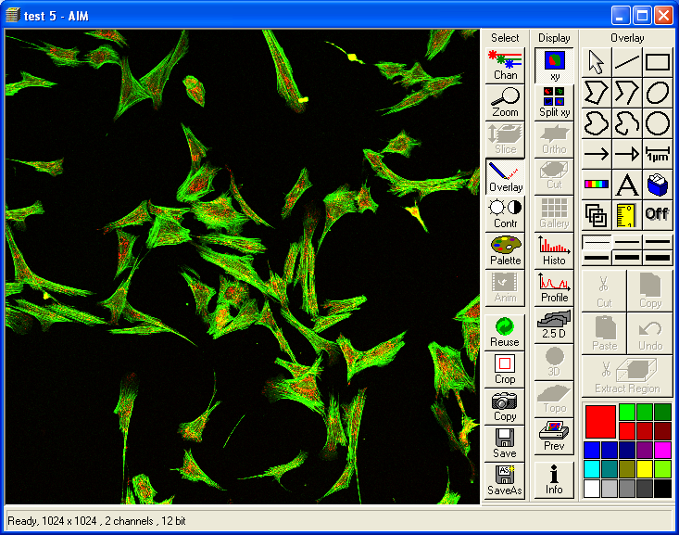
Overlay brings up options to make scale bars or other annotations (lines, shapes, text). Highlight the inserted annotation to move it, change the line/font color, or delete it.

To save the displayed image, click on Save or Save As.

- When saving an image for the first time, you will be prompted to assign our image a name and a database (MDB) to which it will be added. If this is a new series, select New MDB. A folder and a .mdb file will be created. Save your images in your folder on the D:/.
- All saved images in a database are accessible through the new window that now appears. (To reopen this widow, click File on the main menu then Open, and select the database file you wish to view.) View other images in this database by pressing the arrows in Form mode, or select Gallery to se thumbnails of all images.

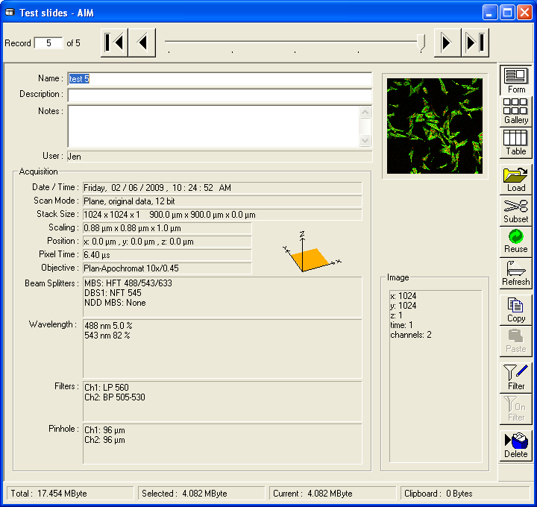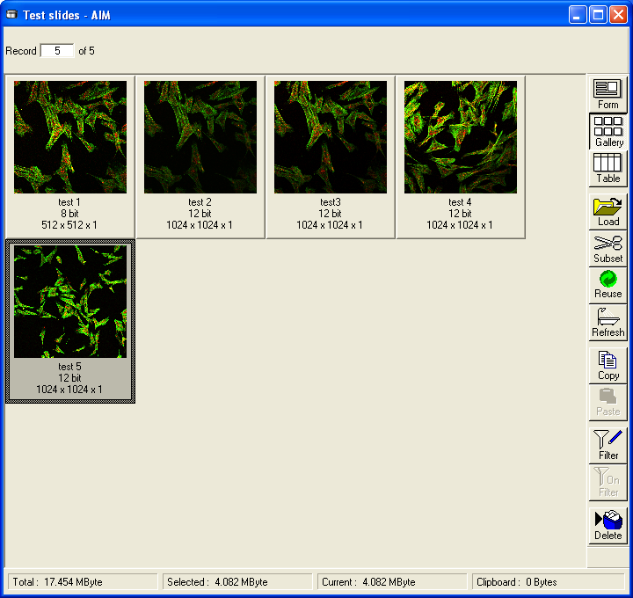

- Before exiting, you must export your images to another format (e.g., TIFF). You need to open up each file and do this individually. Use Gallery mode and Load each image (highlight all to load all at once). Select Export from the main menu. You will have to rename your files. Remember to back up your data to another storage device!

Creating Z Stacks – Some Notes and Features
This feature allows you to scan multiple planes (slices) through your specimen at defined intervals. Adjust the following settings during optimization:
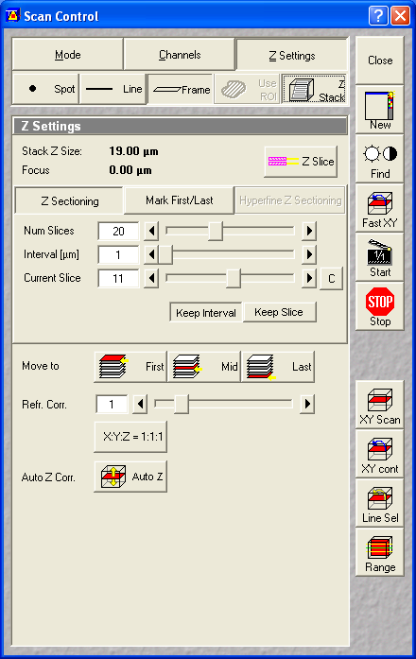
Z Sectioning:
Set the number of slices you wish to capture, the distance between successive slices, and the slice number of the currently in focus image.
Keep Interval will keep the interval setting constant as other settings are adjusted; Keep Slice keeps the slice number constant.

Mark First/Last:
To determine the optimum stack size, click on XY cont, and mark the upper and lower bounds of your stack.

Move to …:
Scans/displays the First, Middle, or Last slice of the stack. Use this to verify that your first and last slice settings are the outer bounds of what you wish to capture.

Auto Z:
Allows settings (detector gain, amplifier gain/offset) to vary linearly between slices. Clicking on this will prompt you to determine settings for two reference slices; middle slices then use interpolated setting values. Helpful if you have uneven brightness among slices.

Take your final image with Start (“Single” now reads “Start”). Be sure that you have adjusted your settings as desired before beginning a stack scan, since scan time is lengthy and some signal bleaching can occur. Again, using a lower resolution (e.g. 256) for optimization is recommended.

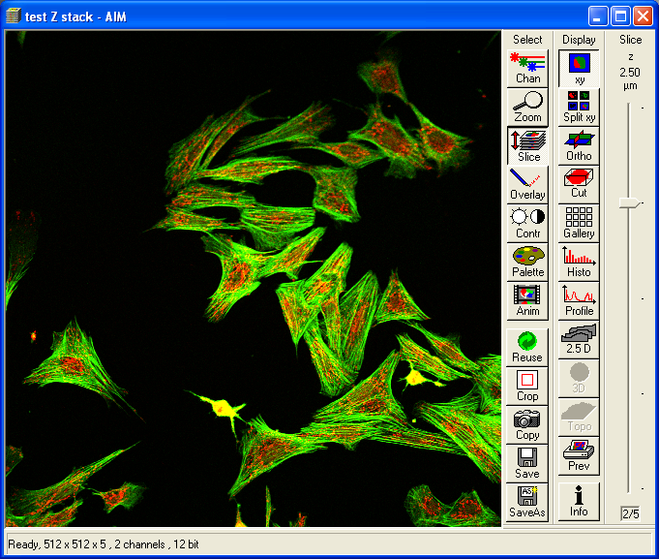
The image display window has a few additional options for Z stacks, including:

Slice – brings up a slider bar (shown on the right side of the image display window) to let you view each slice

Anim – to play through captured slices; can set speed of animation, start/stop, etc.

